# EXPERIMENT 7

# Construct a C program to implement non-preemptive SJF algorithm

**AIM:** Construct a C program to implement non-preemptive SJF algorithm

**ALGORITHM:**

* 1. Include necessary headers:

Include the necessary header files like <stdio.h> for input/output operations.

* 1. Define the process structure:

Define a structure to hold the process information, such as process ID, arrival time, burst time, waiting time, and turnaround time.

* 1. Input the number of processes and their details:

Input the number of processes and their arrival time and burst time.

* 1. Sort processes by burst time:

Sort the processes based on burst time in ascending order.

* 1. Calculate waiting time and turnaround time:

Calculate the waiting time and turnaround time for each process based on the non-preemptive SJF scheduling algorithm.

* 1. Display the scheduling information:

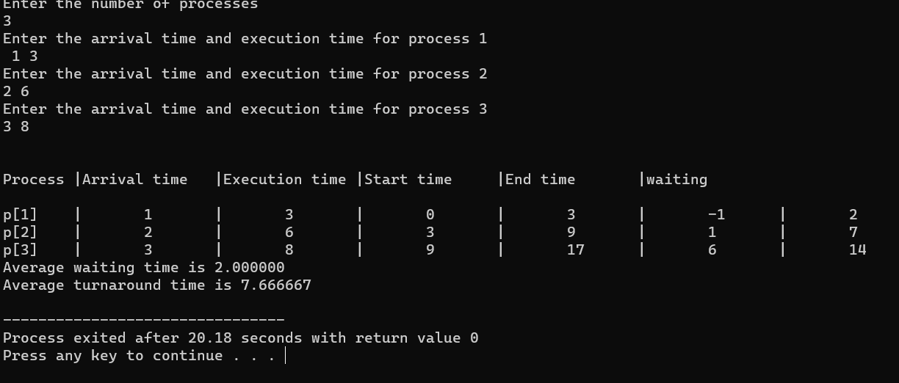Display the process details including process ID, arrival time, burst time, waiting time, and turnaround time.